**Project Record Template**

INTRODUCTION

* 1. Overview

**CRM application that helps to book a visa slot.**

This will help you to track and manage the availability of visa slots which are appointments that are required for certain visa application. It might be used by a government agency or a visa processing center to schedule and manage appointments with applicants. The CRM application for visa consultants must have the ability to deal with agreements to universities. The CRM solution for visa consultants can generate the invoices to institutes as well as agents. It must have role wise security.

* 1. Purpose

A visa is an official permission that a certain country needs to grant a passport holder of another country before their visit to the former country.

Visa cards are payment cards that use the visa network.

Financial institution partner with visa to use the company’s network.

Visas are granted to people who work or plan to attend school in a nation for a select amount of time.

Visa have time limit and typically that time extends to about six months.

It helps us safe and and allow us to see and travel the world.

PROBLEM DEFINITION & DESIGN THINKING

2.1 Empathy map

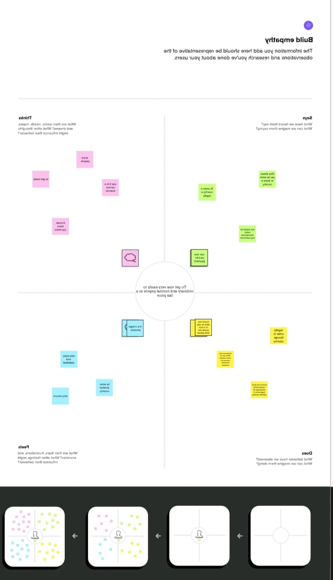

2.2 Ideation & Brainstorming Map

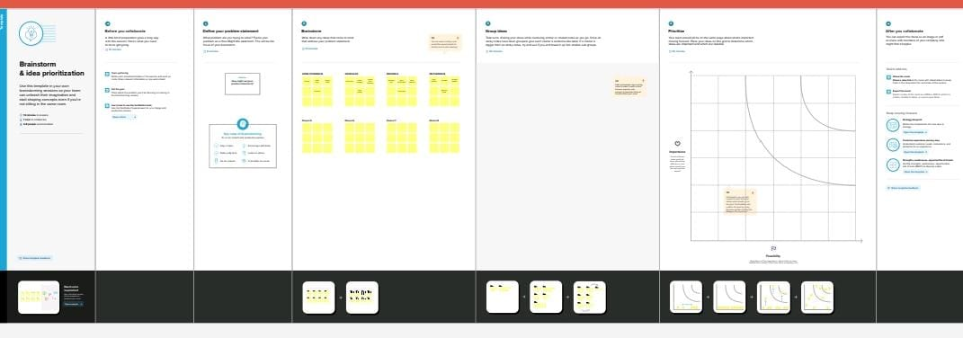

RESULT

3.1 Data Model

|  |  |
| --- | --- |
| Object Name | Fields in the Objects |
| 1.passport | |  |  | | --- | --- | | Field label | Data type | | full name | text | | passport number | text | | Contact number | number | | Permanent address | text | |
| 2.visa | |  |  | | --- | --- | | Field label | Data type | | location | text | | time | number | | Passport number | text | | Visa slot number | number | |

|  |  |
| --- | --- |
| Object Name | Fields in the objects |
| 3.Reschedule/Cancel | |  |  | | --- | --- | | Field label | Data type | | Passport number | text | | location | text | | time | number | | cancel | text | |

3.2 Activity and screenshot

* Sign in to the salesforce.
* In home tab navigate to setup and select object manager and create a custom object defintion.

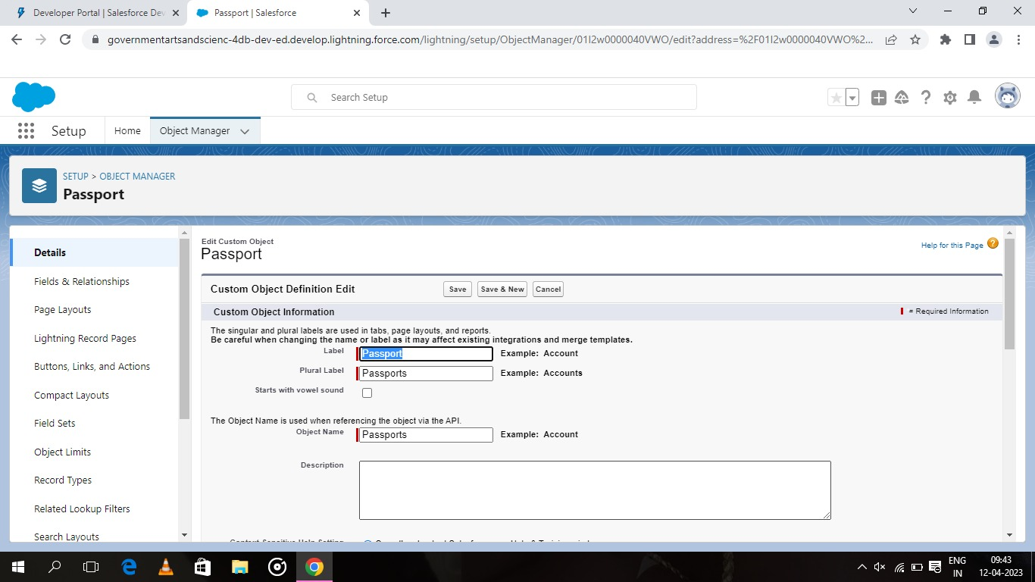

* Creation of field on custom object:Passport

Select your object from object selection has passport and

select the option fields and relationships.

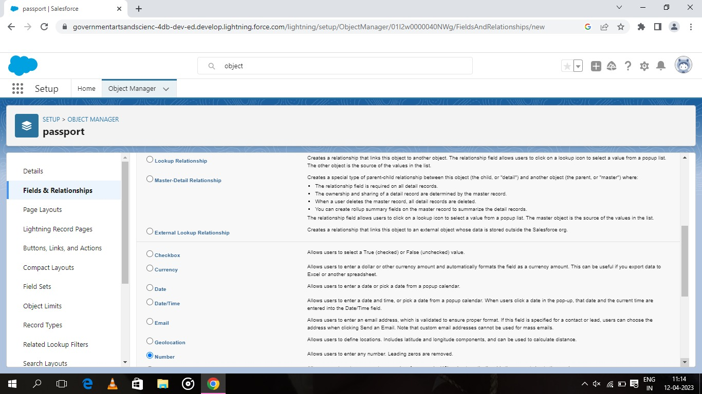

select new and data type has number.now you will navigate to enter the detail page of field label.enter field label has contact numberand length as 10.

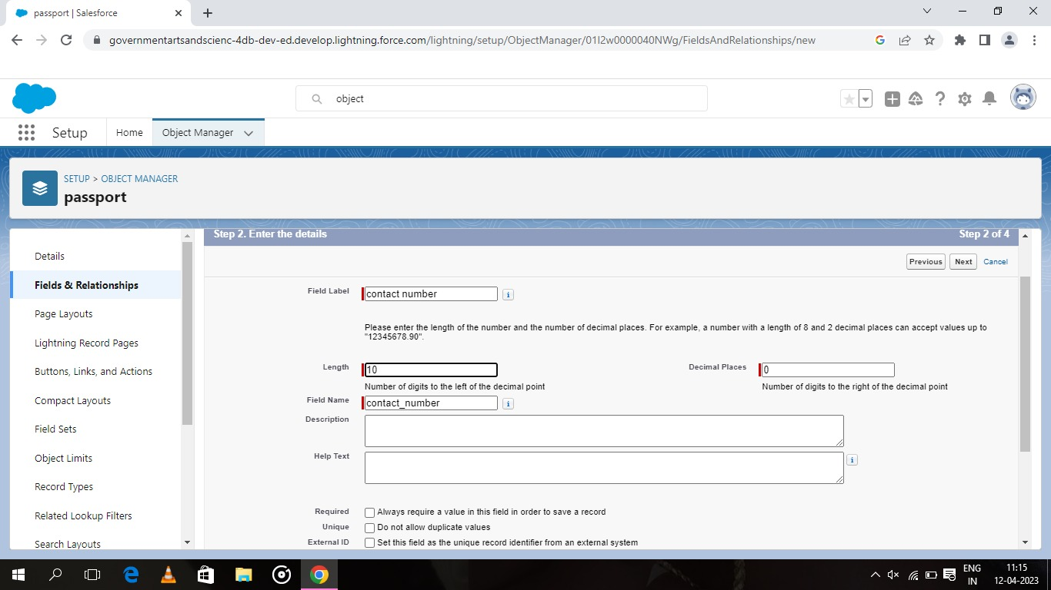

* For creation of relationship

Go to object manager and select visa object and select fields and relationships and click new.and select the data type has master detail relationship.

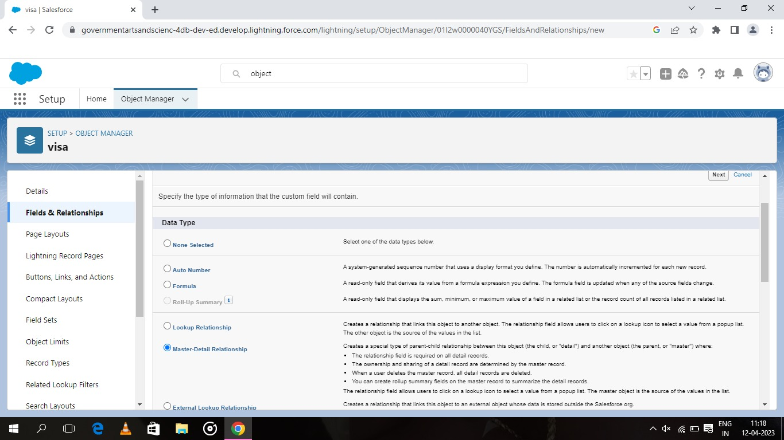

And select related to the object has passports and click on next.

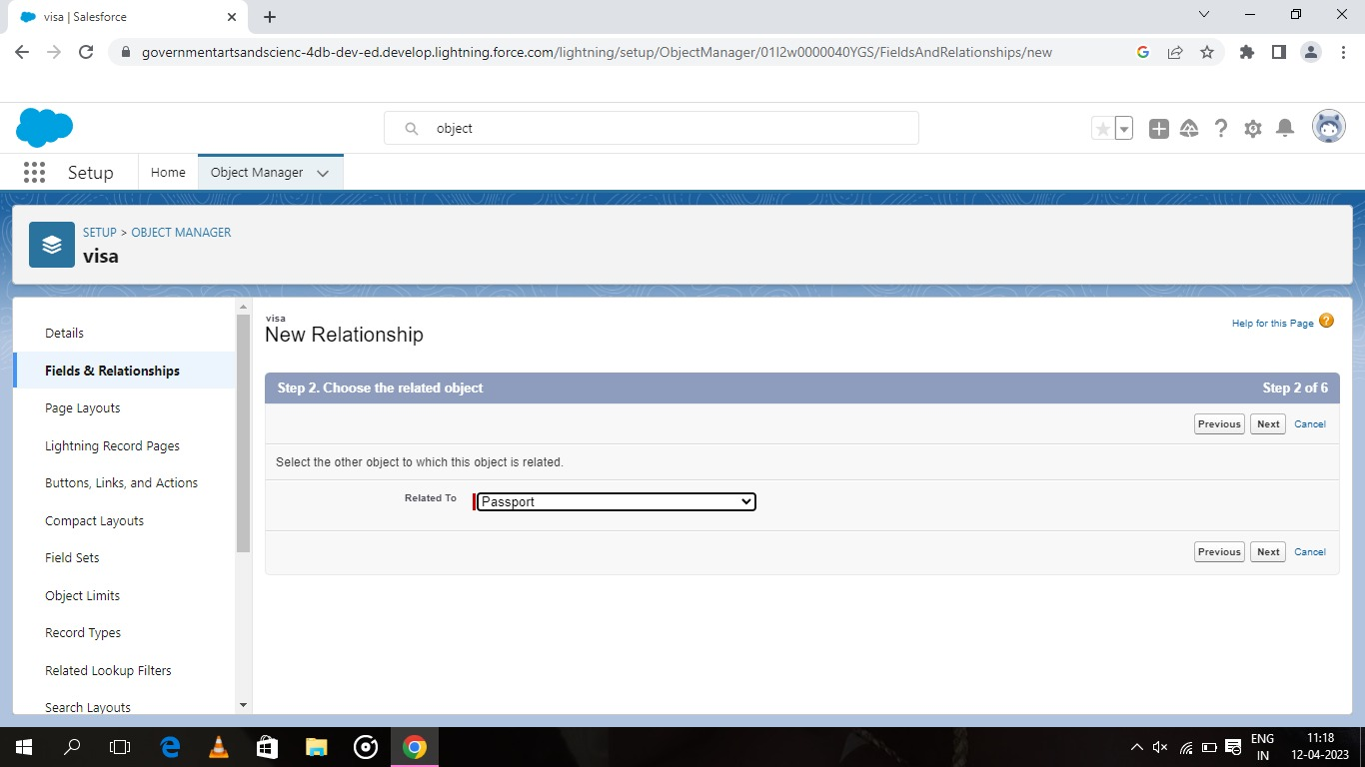

You will navigate to label name page and give the label name has passport number and click next

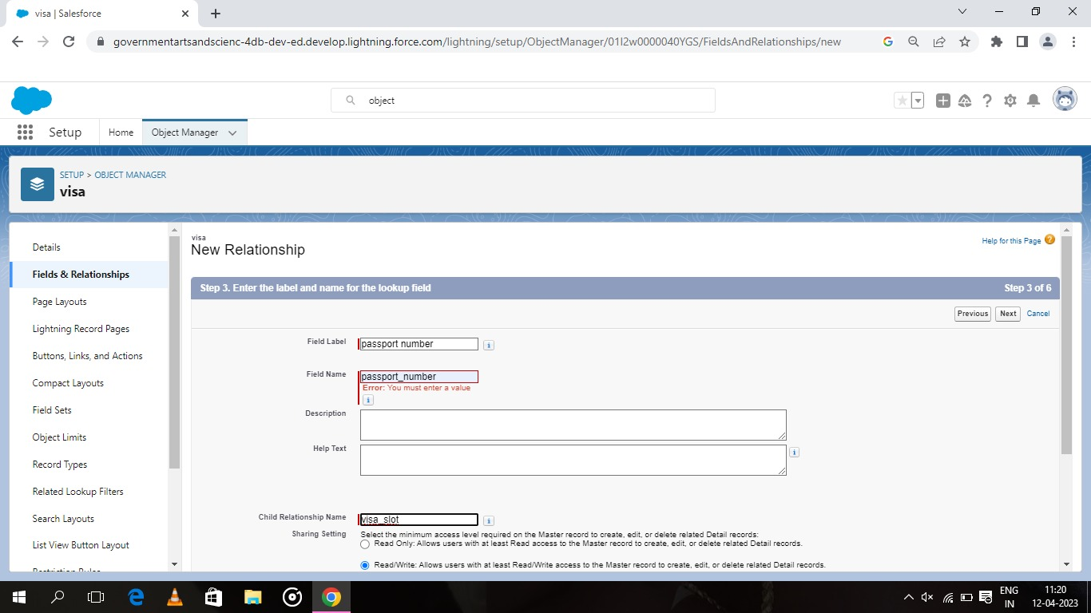

* For creation of app

Navigate to setup and search for app manager.and select new lightining app.give the app name has book my visa.upload the picture and click next.

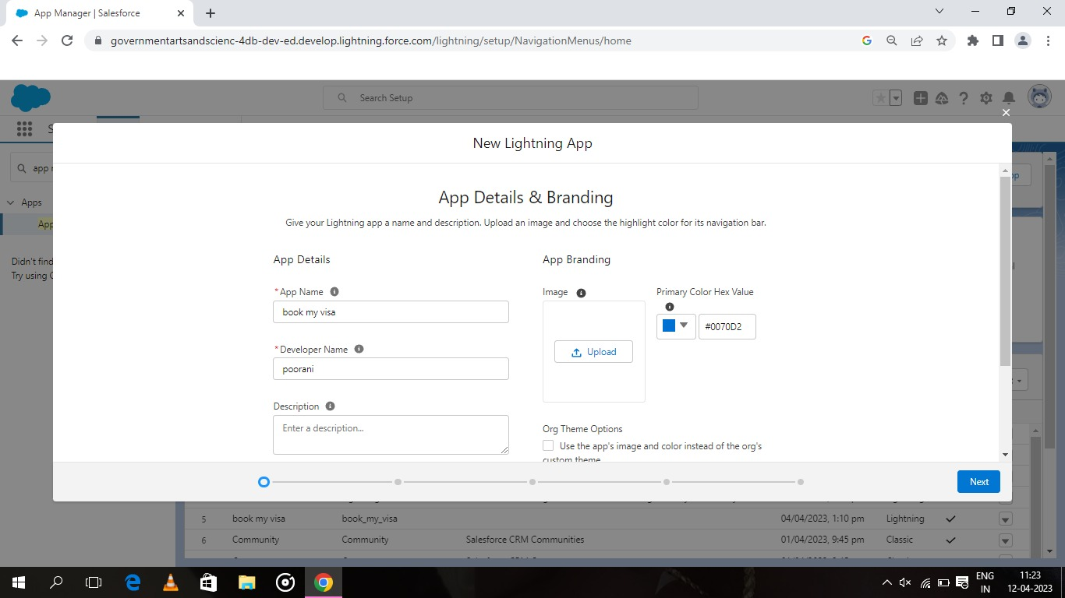

upload the picture and click next.choose the option as navigation style-standard navigation,support from factors-desktop & mobile and select next.

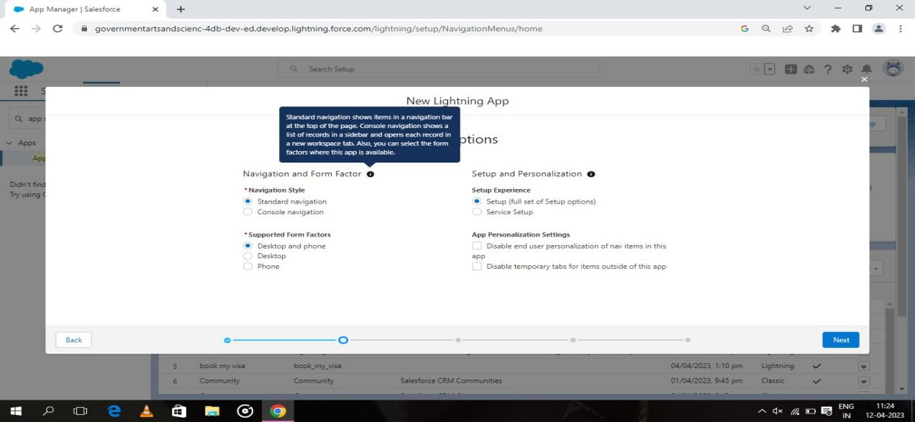

Move the object from available items to selected items.and system admin profile to available items to selected items.

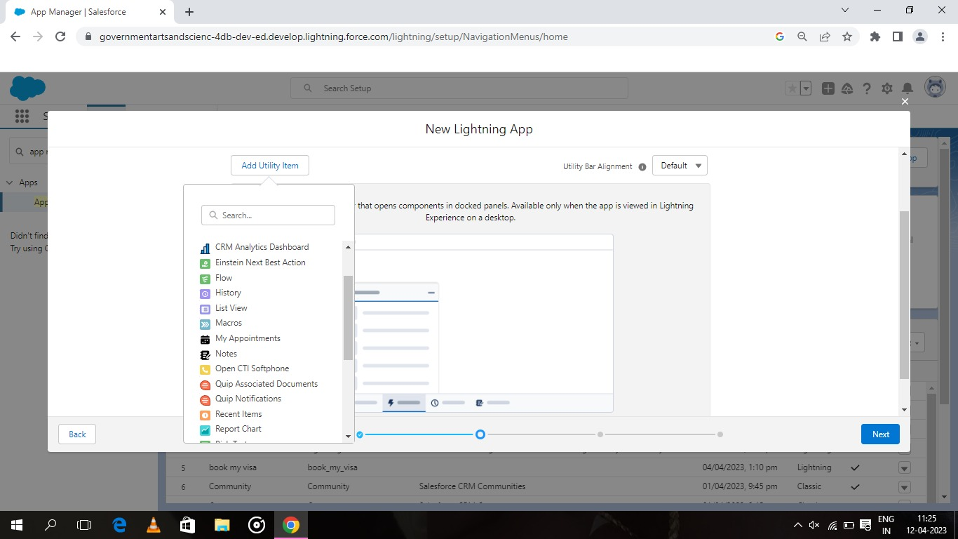

* For creation of user

In setup quick find search bar type user and select.

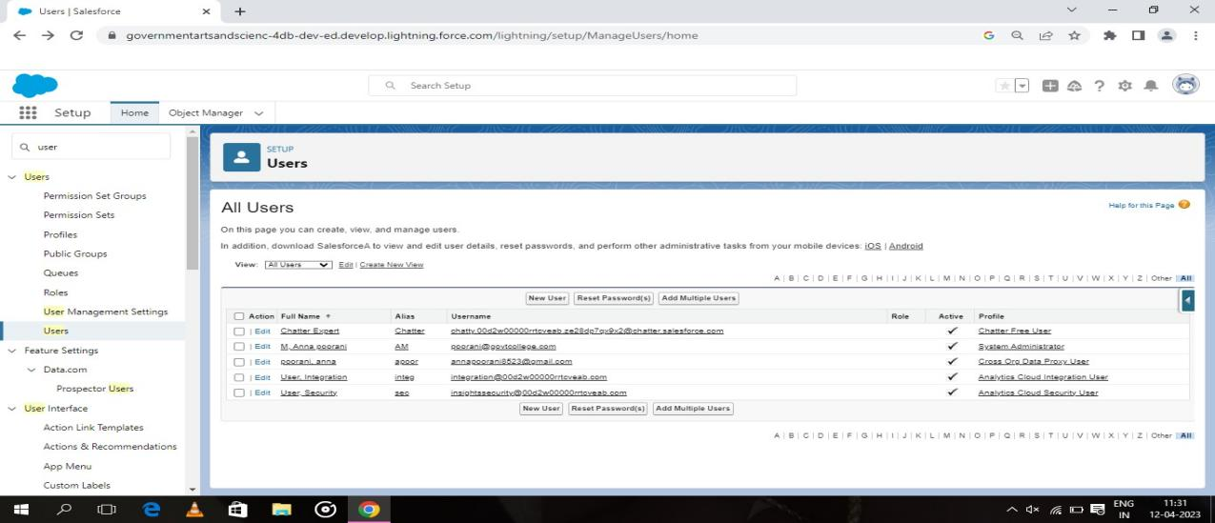

Now click new user.give the first name and last name and enter you e mail.select the user license of salesforce.in profile field select standard user.

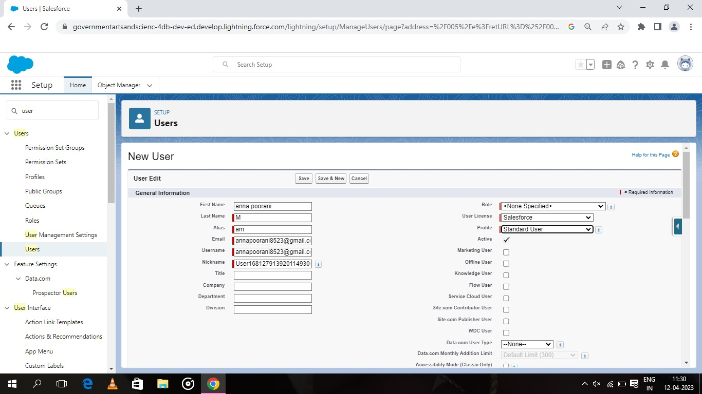

At the bottom of the page check the box to generate a new password and notify the user immediately.

* OWD

In setup find search bar type sharing setting and you will be navigate to sharing setting page.

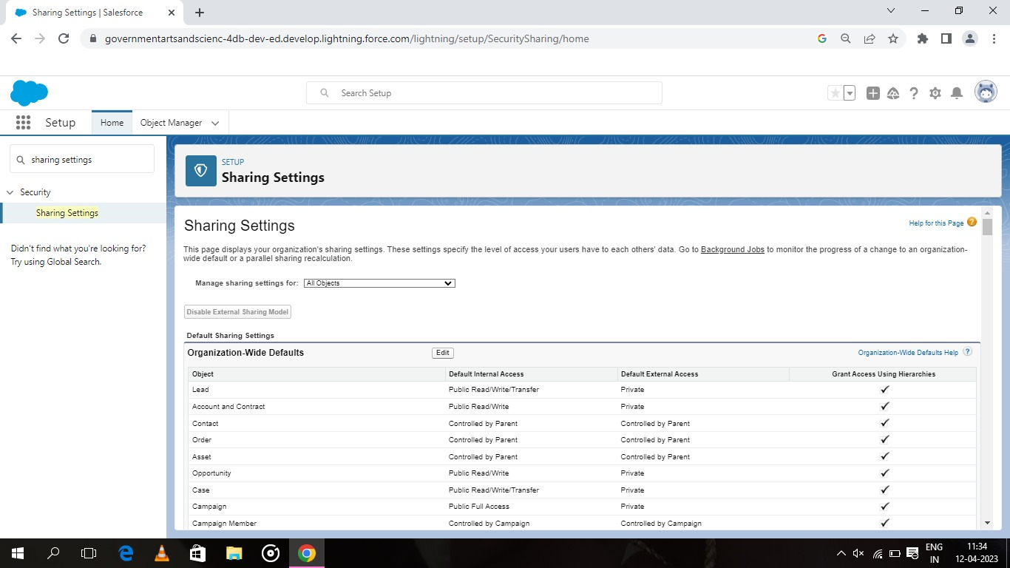

Go down to the page select owd and click edit.navigate to bottom of the page and select passport object.and change the default external access to public/read/write.

* For creation of reports

Click on app launcher and search for reports and select new report.

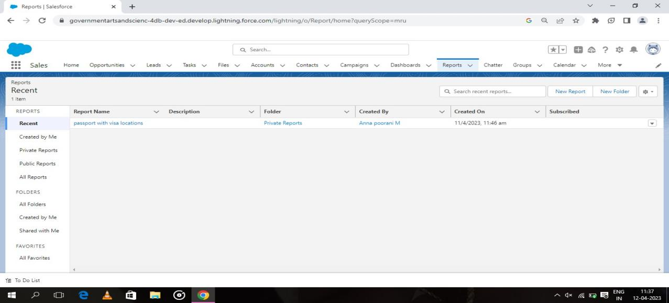

In outline section select your record details and fill group and columns.

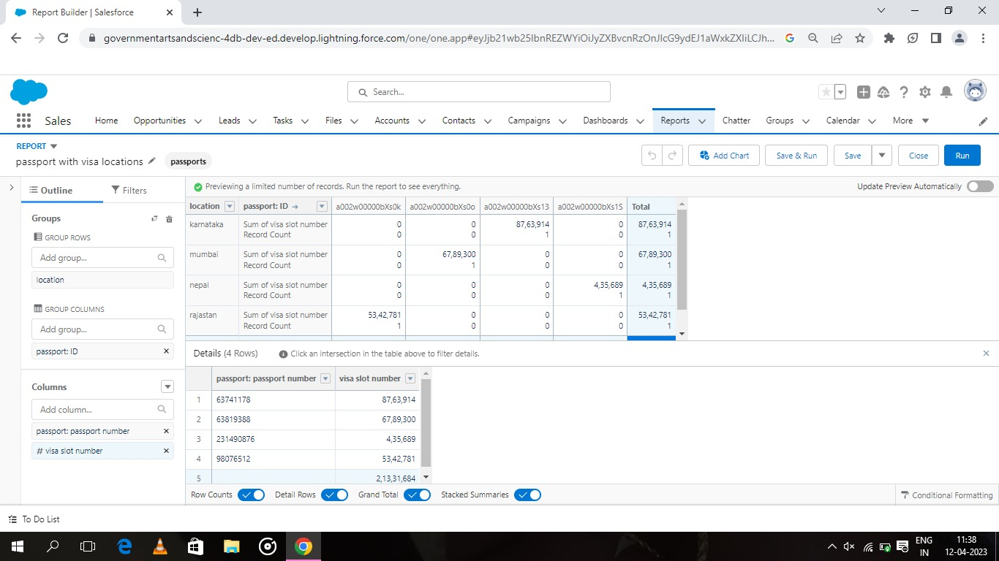

Now navigate to filter panel and select all passwords.click on save and run for saving the reports.

* For creation of dashboard

In app lancher select dashboards and make your report as dount chart.

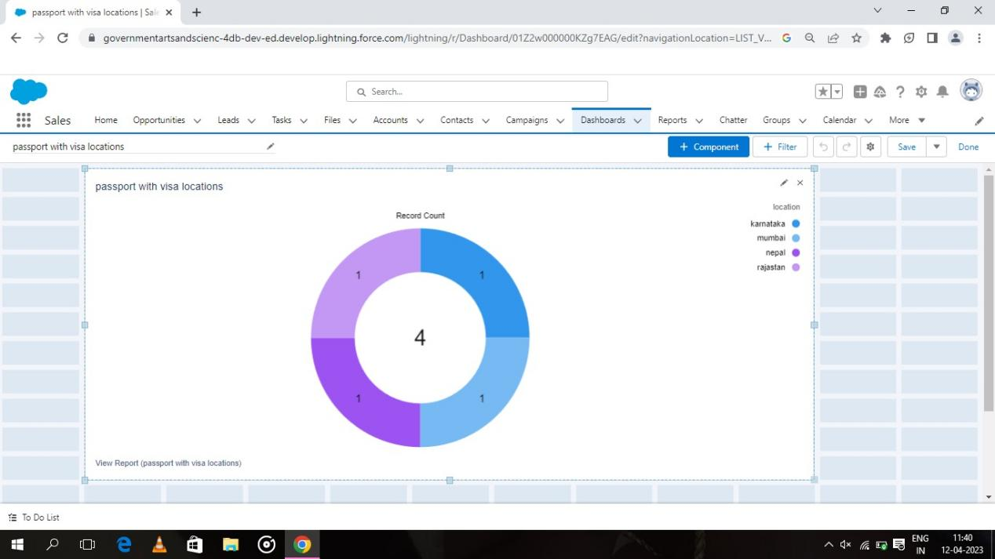

**TRAILHEAD PROFILE PUBLIC URL**

Team leader-https://trailblazer.me/id/ii06m

Team member 1-https://trailblazer.me/id/ReVi2003

Team member 2-https://trailblazer.me/id/aniii2

Team member 3-https://trailblazer.me/id/ii23b

**ADVANTAGES & DISADVANTAGES**

Advantages

* Easy way to handle.
* High information are secured.
* Passenger details are stored in proper manner.
* Everyone can apply for visa.
* Easy proof of citizenship.
* More work opportunites and you can study abroad.
* No need of additonal documentation and lengthy application for visa

Disadvantages

* Process of getting passport is much harder.
* There is a time limit in the visa.
* Visting all countries through visa is not possible.

**APPLICATIONS**

* For bussiness purposes.
* For students to study abroad.
* For visiting purposes.
* Mostly for tourist.
* Used for citizen proof.

**CONCULSION**

This application is applicable for all the student,senior citizen and all pepole.Eveyone can use this application.This application is more digitalize and make us to feel secure to use.

**FUTURE SCOPE**

In future this type of applications are highly developed and programmed for pepole all over the country.In fututre more features are inculed in this application.